Mocking with mockito

Most essential java unit testing skills is mocking

A java spring boot application is divided in multiple layers
--------Web layer----> business layer-----> data layer---------

When we are writing unit test for web layer we don’t want to worry about business layer
We mock it out

When we are writing unit test for business layer we don’t worry about the data layer we mock it out

Mockito the mocking framework helps in writing awesome unit test for java multilayer application.

Diffrence between junit 5 and junit 4
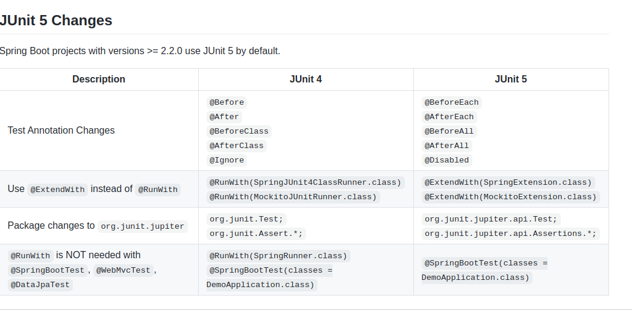

java unit test with stub

What is a Stub?
Stubs are used during Top-down integration testing, in order to simulate the behaviour of the lower-level modules that are not yet integrated. Stubs are the modules that act as temporary replacement for a called module and give the same output as that of the actual product.
Stubs are also used when the software needs to interact with an external system.

Stub - Flow Diagram
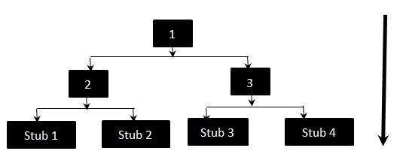
stubs are difficult to manage
cause you have to create diffrent stubs for diffrent kind of data and if one the lower level component changes its functionality all stubs have to be updated.
For example there are hundred stubs of a lower functionality-1 but if lower functionality-1 changes all the hundred stubs have to chnage..

Mocks to replace Stubs
so when we create a stub we hard code the data it will return
but with mockito we can create mocks which will help in creating data low level componenets programatically.

@SpringBootTest
public class SomeTestServiceWithMock {
@Autowired
SomeServiceImpl someService;
@Test
public void testingWithMockForNormalInput(){
/*
* instead of creating stub to generate some data
* we used mockito frame work to programmatically generate data
* according to condition
*/
/*
* so we called mock method of mockito framework from
* import static org.mockito.Mockito.mock;
* to create mock of a class or an interface
*/
SomeDataImpl someDataMock=mock(SomeDataImpl.class);
/*
* and we use when method present in
* import static org.mockito.Mockito.when
* which will generate data programmatically
* so when the mock class or interface method is called
* for example someDataMock.retrieveData()
* return the values thenReturn(new int[]{1,2,3,4})
*/
when(someDataMock.retrieveData()).thenReturn(new int[]{1,2,3,4});
someService.setSomeData(someDataMock);
int actualResult=someService.calculateSumWithDataService();
int expectedResult=10;
assertEquals(expectedResult,actualResult);
}
}

@ExtendWith(MockitoExtension.class)
public class someTestServiceWithMock2 {
@InjectMocks
SomeServiceImpl someService;
@Mock
SomeDataImpl someDataMock;
/*
the above loc 21 and 24
@Mock will create the for the class SomeDataImpl someDataMock;
@InjectMocks tells that the @Mock will be injected to this class i.e
a instance of SomeDataImpl someDataMock will be injected to SomeServiceImpl
i.e it will call the setter in SomeServiceImpl
*/

verification of method call in mockito
for example we have a method let say
public void sendMsg(string msg){
// and at the end of function it calls anothe function
sendHello(msg);
// so we have to verify using mockito that the method is called
}

when we want to launch a specific controller instead of whole application
@WebMvcTest(value = HelloWorldController.class)
public class HelloWorldControllerTest {
// so now we want to call the uri in the controller that is
// @GetMapping(path = "/sayHi")
// and make sure it calls the method linked to the uri
// public String sayHelloWorld(){
// return "<h1>Hello World</h1>";
// }
}

@RunWith(SpringRunner.class)
@SpringBootTest-annotation launches the whole application for testing
it looks for @SpringBootApplication and launches the context and all the components present in it also launches the controller the services the repositories and the in meamory database.
Since we want to launch web application for testing we define webEnviorment in which the testig take place.

We use random port
since application execution and application testing will be done simentaniously we don’t want to run them on same port

so we use
@SpringBootTest(webEnviorment=WebEnviorment.RANDOM_PORT)
private TestRestTemplate which allow us to make calls uri of controller and know port on which the test is running

in integration testing we are checking that all the component are communicating with each other.
We don’t need to access original database in integration testing so @SpringBootTest provide allows us to connect to in meamory databases

use @MockBean to create a mock of the copoent in context gives you easy option to exclude external dependency which we don’t want to use in database.
Focus remain on communication between the layer and indipendent of the external database and external compenent using @MockBean

we can have diffent application.properties files for the unit testing of our java application
we can define it in src>test>resources(create one if not present) > application.properties
it will override the application.properties of the application.

Have a test specification configuration
#to use this specific application-test.properties we use
# @TestPropertySource(locations = {"classpath:application-test.properties"})
# on top of the class
# gives the specific configuration files to specific test

Matching Library
Hamcrest Matchers
Assert J / Jason Assert
JSON Path

